CS 255 System Design Document

UML Diagrams

UML Use Case Diagram

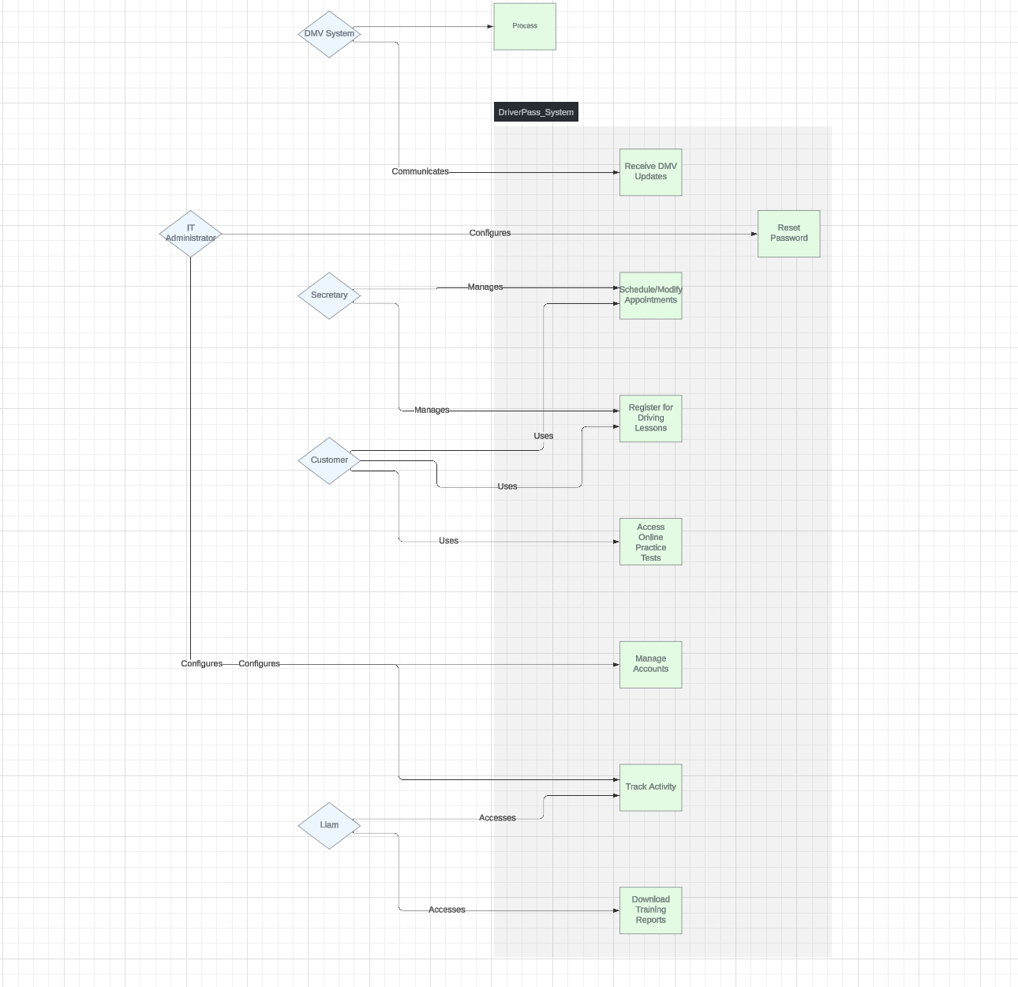

This diagram shows the interactions between the system and its key users, including students, instructors, and administrators. The primary use cases include scheduling driving lessons, managing progress, processing payments, and generating reports. Each use case is aligned with DriverPass’s business needs, ensuring a smooth and user-friendly system.

UML Activity Diagrams

Activity Diagram 1: Schedule Driving Lesson

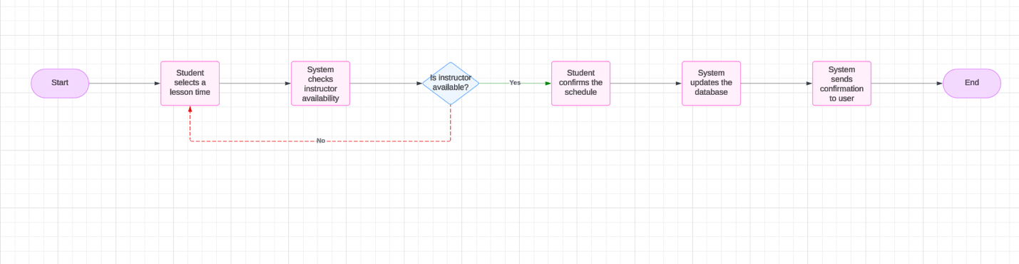

This activity diagram outlines the step-by-step process of scheduling a driving lesson. It begins with the student selecting a lesson time, checking instructor availability, and confirming the schedule. The system then updates the database and sends a confirmation to the user. This ensures seamless booking for students.

Activity Diagram 2: Update Progress

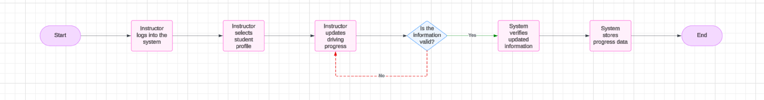

This diagram represents the workflow for updating a student’s progress. After a lesson is completed, the instructor logs into the system, selects the student profile, and updates the driving progress. The system verifies and stores the new information, ensuring accurate tracking for students and administrators.

UML Sequence Diagram

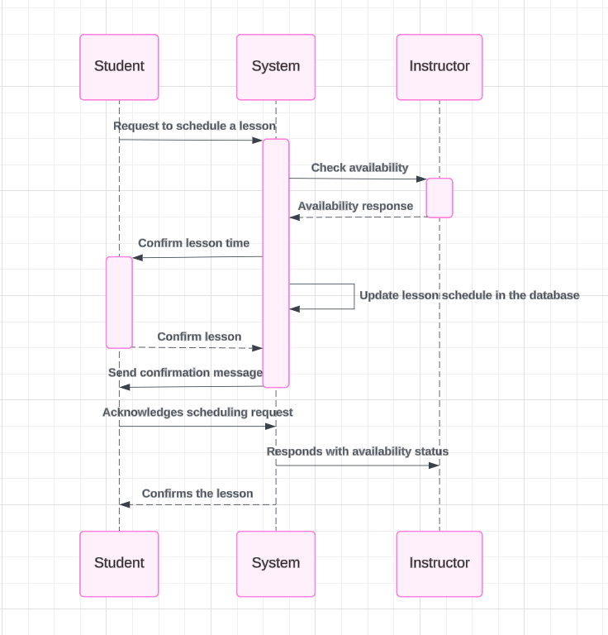

This sequence diagram illustrates the interaction between the student, instructor, and system when scheduling a lesson. It starts with the student’s request to schedule a lesson. The system checks instructor availability, confirms the time, and updates the database. Finally, a confirmation is sent to the student. This diagram highlights the smooth communication and automated processes within the system.

UML Class Diagram

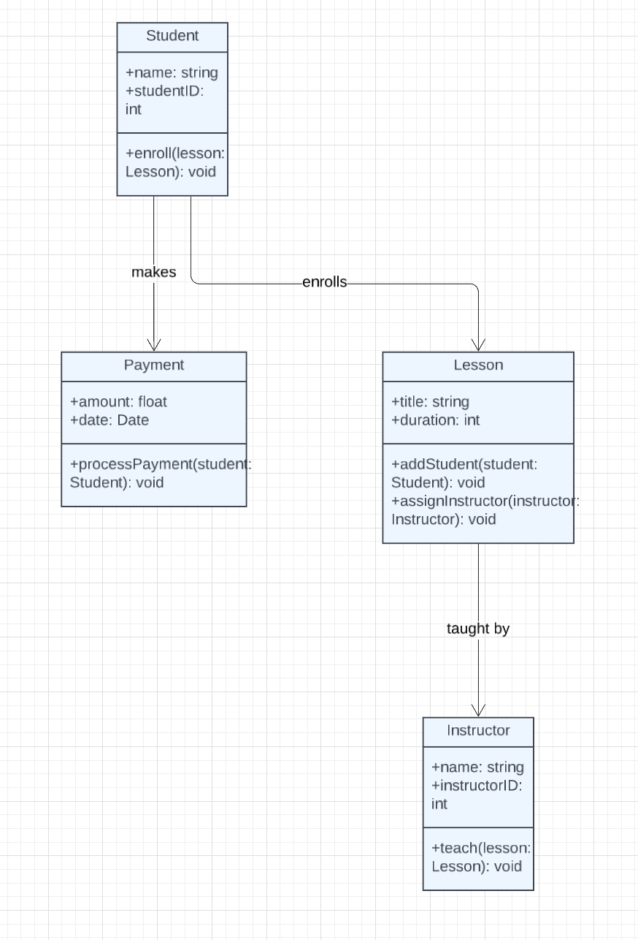

This class structure ensures that all core components of the system are organized, scalable, and easy to maintain. Relationships between classes are clearly represented to show how data flows across the system.

Technical Requirements

The following technical requirements outline the hardware, software, tools, and infrastructure necessary for implementing the DriverPass system:

Hardware Requirements:
- Servers to host the system database and application.
- Workstations or laptops for students, instructors, and administrators.
- Cloud-based storage infrastructure for backups and data security.

Software Requirements:
- Operating System: Windows Server/Linux for server hosting.
- Database Management System (DBMS): MySQL or PostgreSQL for data storage.
- Web-based Application: Built using front-end frameworks (React or Angular) and back-end technologies (Node.js, Java, or Python).
- Browser Compatibility: Chrome, Firefox, and Safari.

Tools:
- Lucidchart for UML diagrams.
- Version Control: Git for tracking changes to code.
- Development Tools: Visual Studio Code, Eclipse, or IntelliJ IDEA.
- Testing Tools: Selenium for automated testing and manual testing frameworks.

Infrastructure Requirements:
- Cloud Hosting: AWS or Azure for scalable hosting solutions.
- Security Infrastructure: SSL certificates for secure connections, firewalls, and access control systems.
- Backup and Recovery: Regular backups to ensure system resilience and protect user data.

These technical requirements ensure that the DriverPass system is robust, scalable, and meets the client's functional and nonfunctional requirements. The system will provide a reliable platform for students, instructors, and administrators to seamlessly interact and manage driving lessons.

